Opsmanager Backup Daemon Configuration

1. Create the HEADDB directoty on Ops manager server and set the owner ship as “mongodb-mms”



Check the backup daemon service status. It should be in running state.

# /etc/init.d/mongodb-mms-backup-daemon status

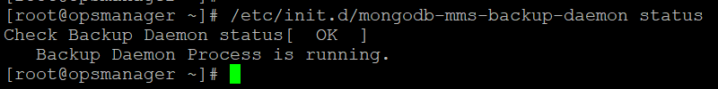

Go to the “Admin” console (highlighted in yellow)

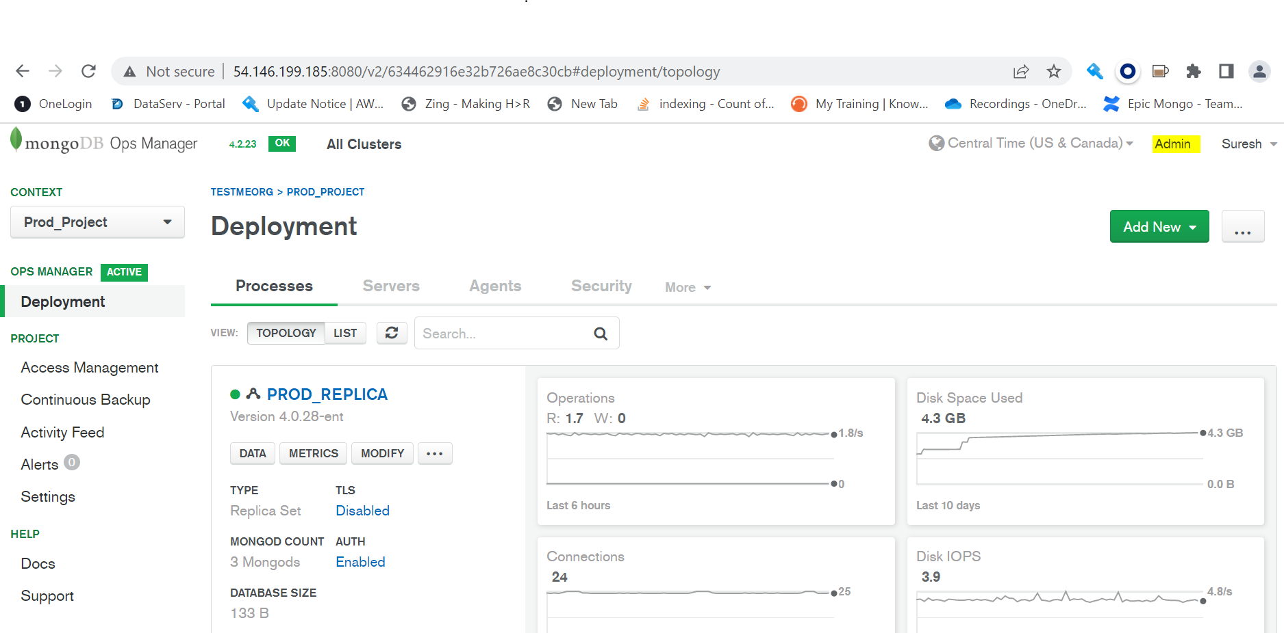

Click on Backup Icon and configured the head DB path and click on Set button.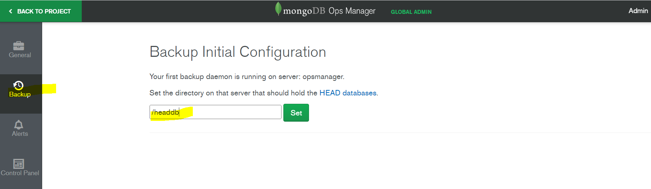

Click on “Enable Daemon” button

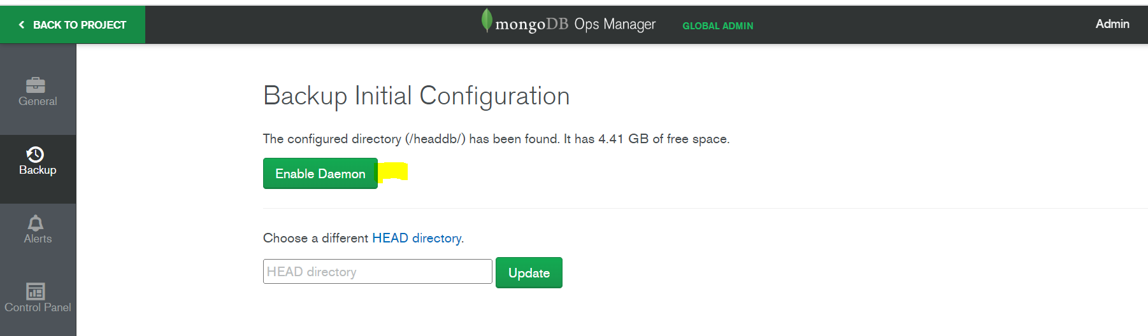

Once you enabled the backup daemon, You can store the backup snapshot three way. Options are shown in below screenshot

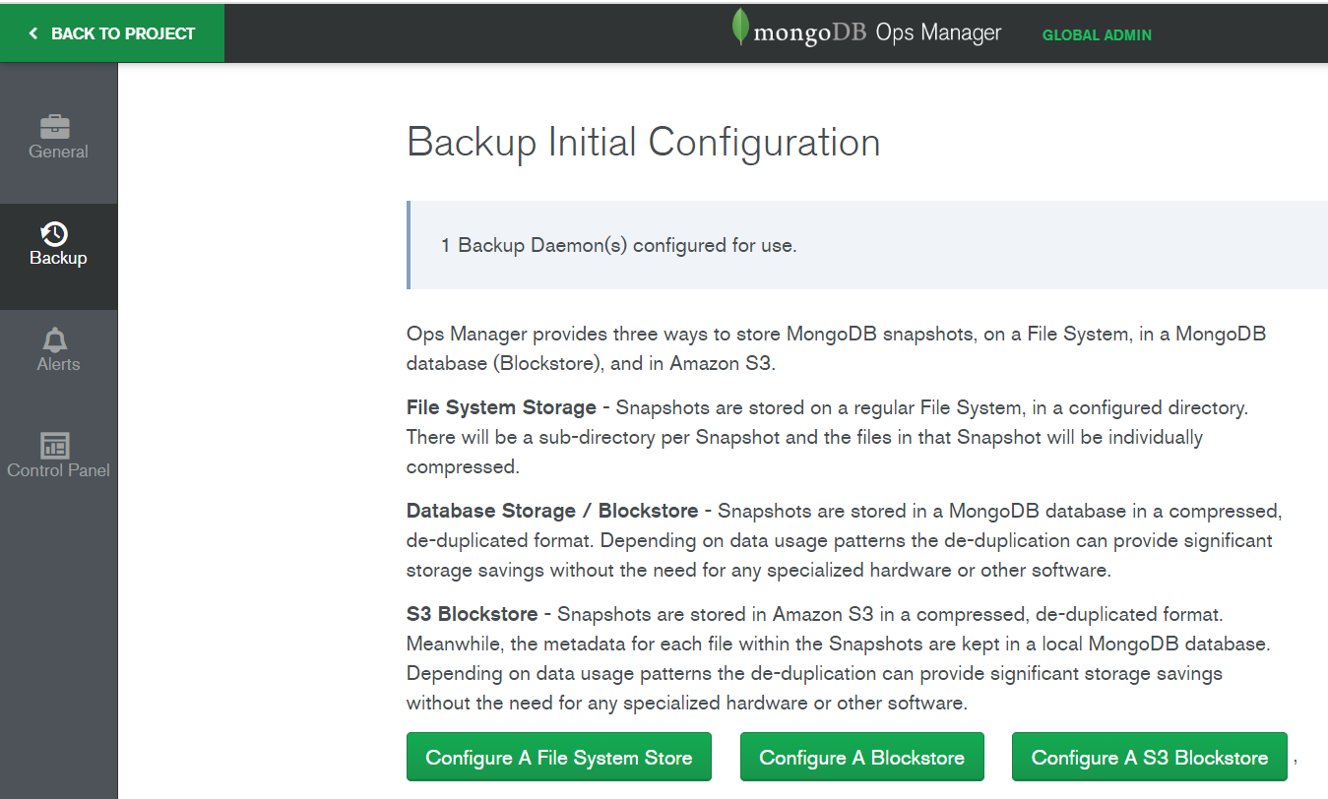

Here we are configuring File System Store

